Accepting a trainee
For a supervisor to accept a trainee, they must follow these steps:
- Login to the College’s website
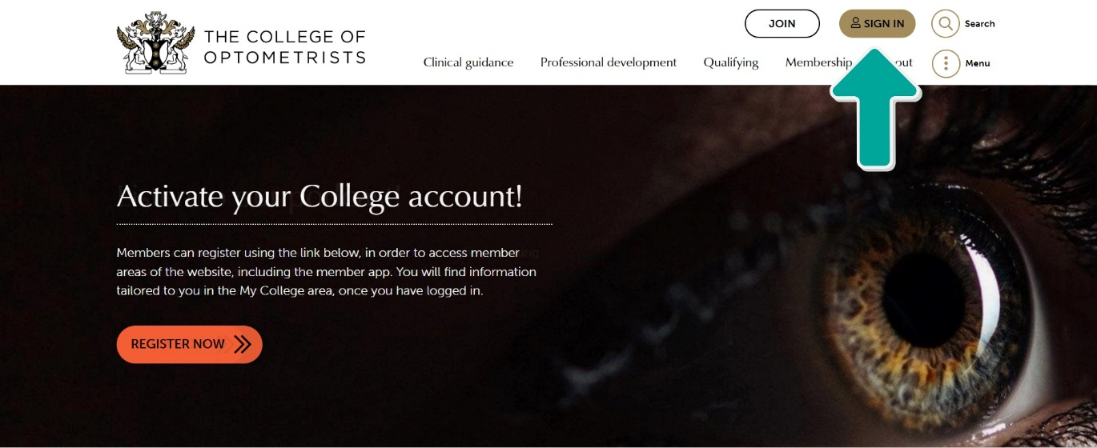

- Or click “My College” at the top of the page
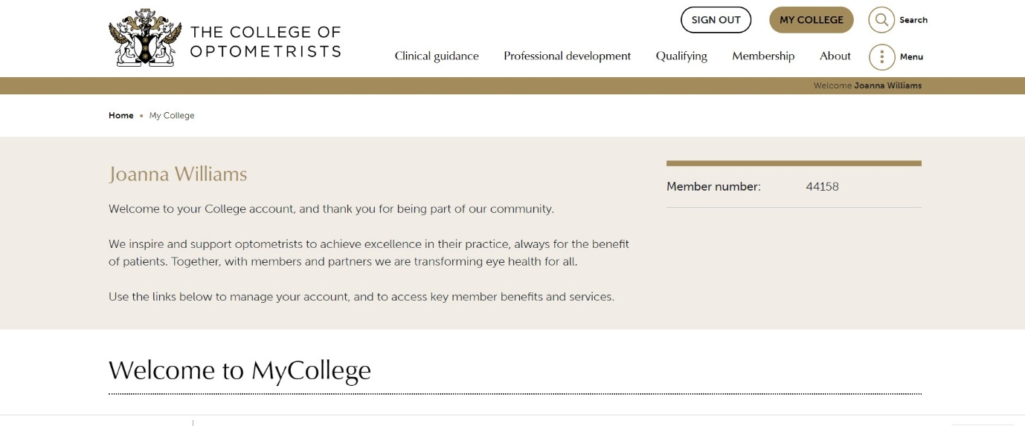

- Click on the Scheme for Registration
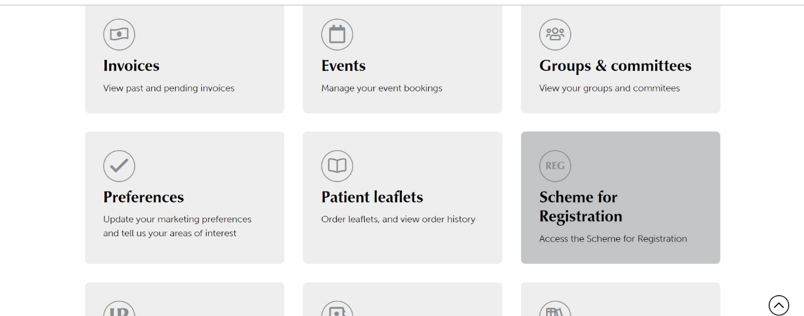

- Click on Trainees
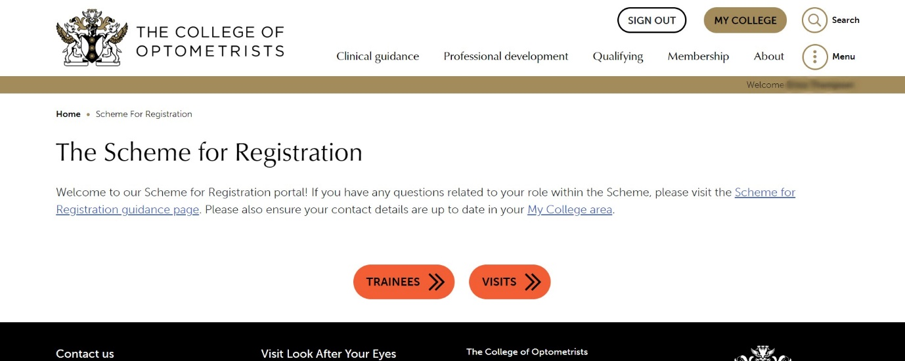

- Click the trainee name and accept.
